ALPINE ASCENTS: USER GUIDE:

|  |  |  |
| --- | --- | --- |
| Supervisor | Ambreen Shamshair Ali | |
| Batch |  | |
| Group | B | |
| Serial No. | Enrollment No. | Student Name |
| 1 | 1473982 | Ambreen Shamshair Ali |
| 2 | 1473624 | Zainab Waseem |
| 3 | 1473625 | Rimsha Hanif |
| 4 | 1463422 | Wadain Imran |

1.navbar(index.html):

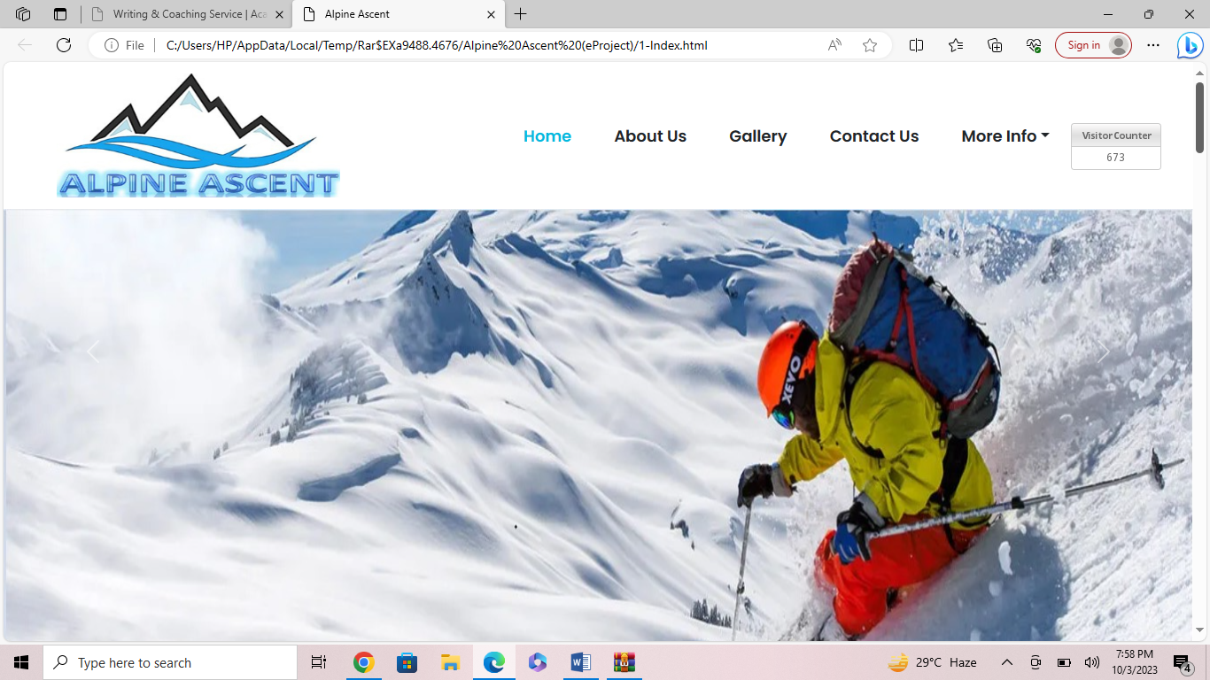

Figure 1: Navbar

We have given five essentials. By clicking any of the essential’s

and redirect to the linked page. (0. Index (1).html)

2.welcome to alpine ascents:

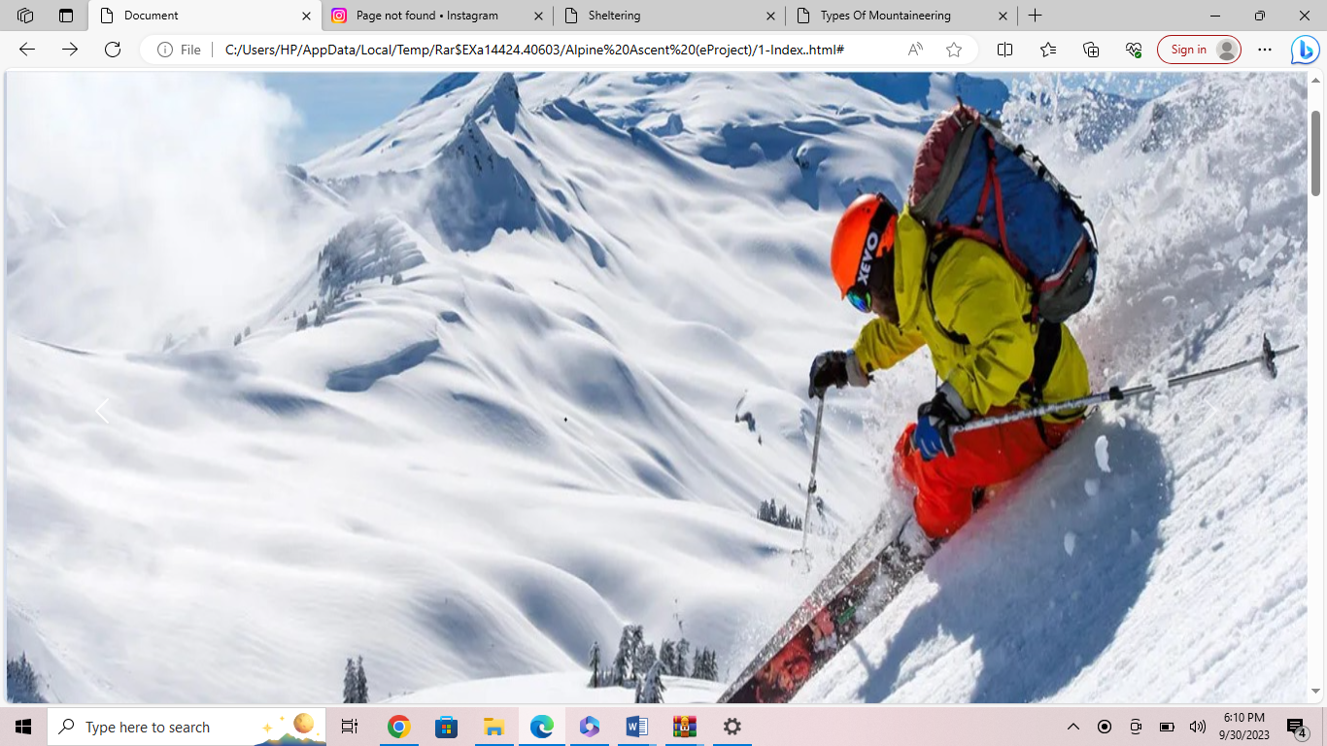

Figure 2: Welcome To Alpine Ascents

Celebrating 37 years of leading successful expeditions in 2023, Alpine Ascents International, Inc. is a leader in the climbing industry and has been instrumental in setting guiding standards in the international climbing community for most of our history. This year, we will offer more than 30 different expeditions and 50 training courses in 14 countries, including the Arctic and Antarctic regions

3.Latest developments:

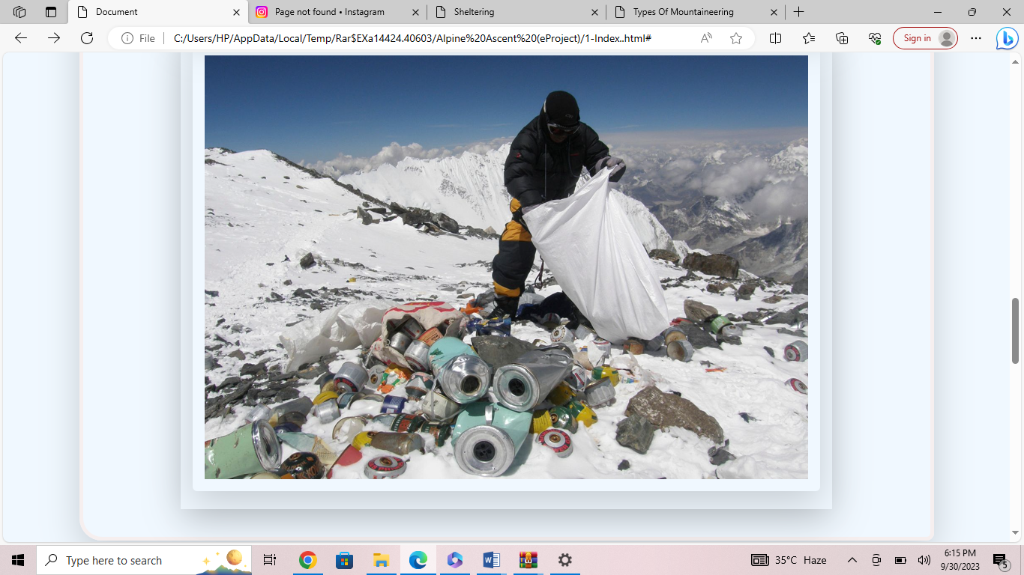

Figure 3: Latest Developments

We are campaigning to protect Scotland’s mountains and wild land from insensitive developments, whether its industrial-scale wind farms, poorly designed structures or unsightly bulldozed tracks. Read on for an update on what’s happened so far, what happens next and how you can help further.

4.Services Prices:



Figure 4: Service Prices

As there are many unforeseen circumstances that may occur during or leading up to the trip, we highly recommend trip cancellation insurance. In many situations, this may be the only way to receive a refund for unused services. In brief, trip cancellation insurance may allow you to get reimbursement if you need to cancel your expedition when you are not entitled to a refund from Alpine Ascents. Alpine Ascents International offers a plan in conjunction with our travel insurance partner.

5.Office Staff(about us.html)



Figure 5:office staff

We have given the information about our workers which helped in creating alpine ascents.

6.Mission:

Alpine Ascents’ philosophy is based on a true love and understanding of mountain wilderness. Our mission and goals are simple: By using the best climbing talent in the country, we offer the opportunity for climbers at all levels to achieve their personal aspirations through quality, challenging, safety oriented, environmentally friendly, ethically sound and fun expeditions/courses. We also look to provide guides an outstanding and career developing work environment.

7.About us Blogs:

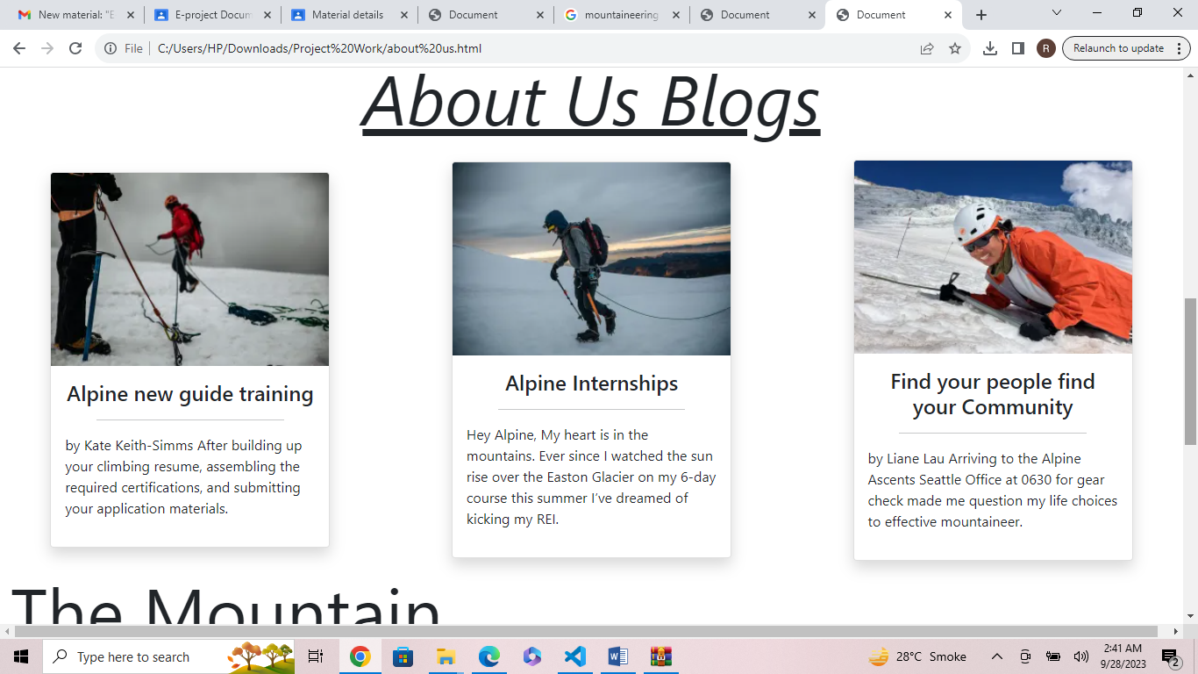

Figure 6: About us blogs

You can visit our blogs and see what people have to say about us also you can see people who want to join us and connect with people who share same interest with you

8.The Mountain:

Mt. Everest, rising 29,031.69 ft. (8,848.86 m) above sea level reigns as the highest mountain on Earth. Since the first ascent in 1953 by Edmund Hillary and Tensing Norgay, reaching the summit of Everest has been considered one of the greatest achievements in mountaineering. Every spring, Alpine Ascents International embraces this challenge, taking a group of qualified climbers to climb Mt. Everest via the South Col route in Nepal.

With over 25 years of guiding experience on Everest, Alpine Ascents is recognized as the premier guide service to provide you a truly rewarding experience climbing to the summit of the highest mountain in the world. We are known for the quality of our logistical services and the expertise of our guides, Sherpa team, and Base Camp staff. We have the latest technology in weather forecasting and communication systems both on and off the mountain. Our Base Camp services, which provide private tents and well-prepared meals by western trained chefs allow you to relax and regain strength when returning from your acclimation climbs.

On the mountain, our guides and Sherpa are focused on your welfare and safety. Our philosophy is that by working together as a team we will climb safer and have more climbers reach the summit. Through leadership and excellent climber care, this has proven true year after year, giving us the highest success rate on the mountain and an excellent safety record of alpine ascents.

9.Innovation:

Alpine Ascents has always been on the cutting edge of innovations in guiding. In 1991, we co-founded the Russian company, Poisk, and designed the Poisk Oxygen Cylinder, which is still the lightest and most efficient bottle used on the mountain today. In 1992, we led the first successful guided expedition to Everest along with Rob Hall’s team. That year we also introduced the idea of (and helped facilitate) bringing Russian Mi-17 helicopters to Nepal to provide more reliable expedition transportation to the mountain. Alpine Ascents pioneered the idea of a 24-hour Everest and Lhotse summit climb, and in 2012, we led the first guided expedition up Everest and Lhotse, putting three climbers on top of two 8,000 m peaks in under 24 hours. This had never been achieved before, guided or otherwise.

10.Gallery( gallery .html):

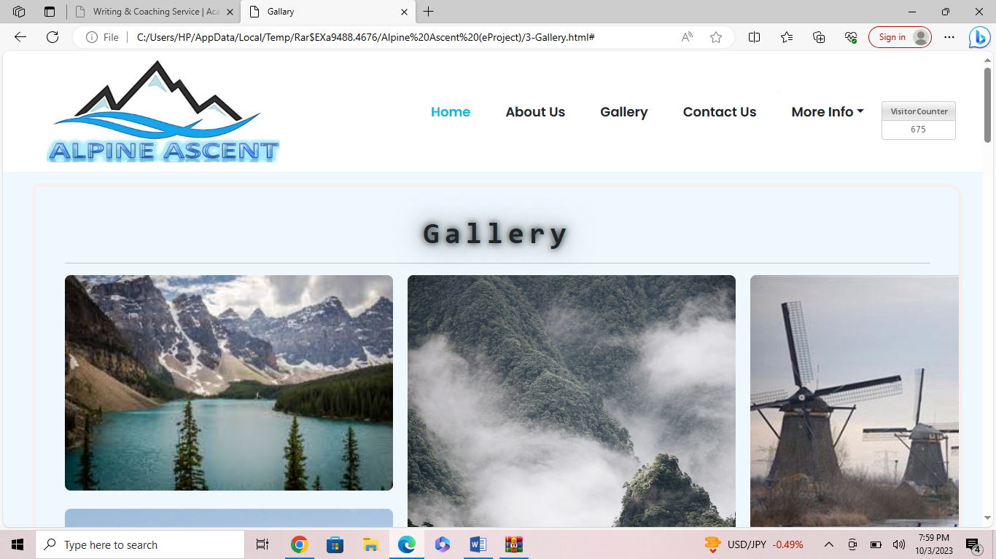

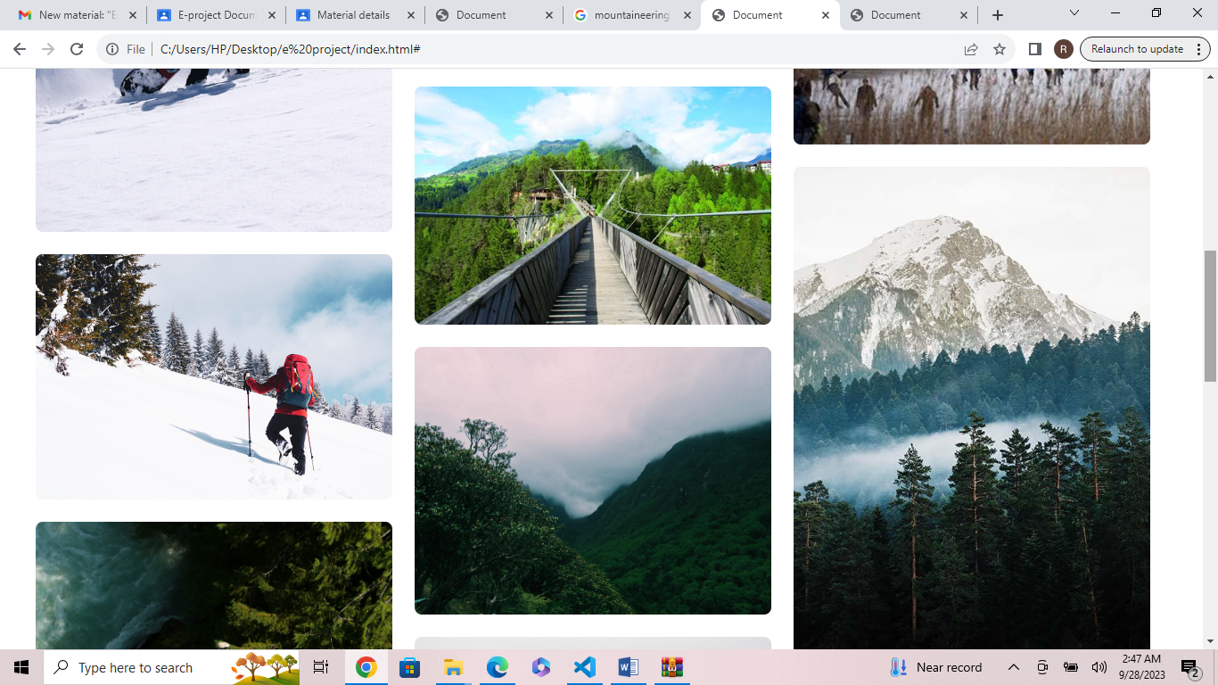

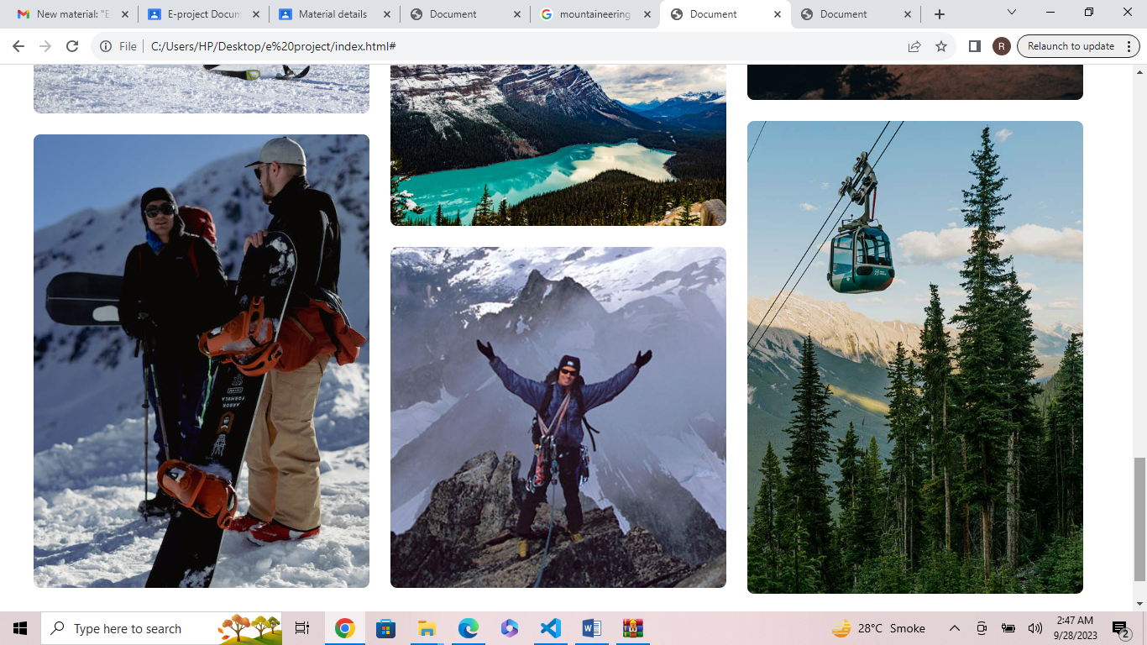

Figure 7 , 8 & 9 : Gallery

We added some pictures to guide about our location and adventures. In these pics you can see the atmosphere and beauty of our site.

11.Contact us: (contact us .html)

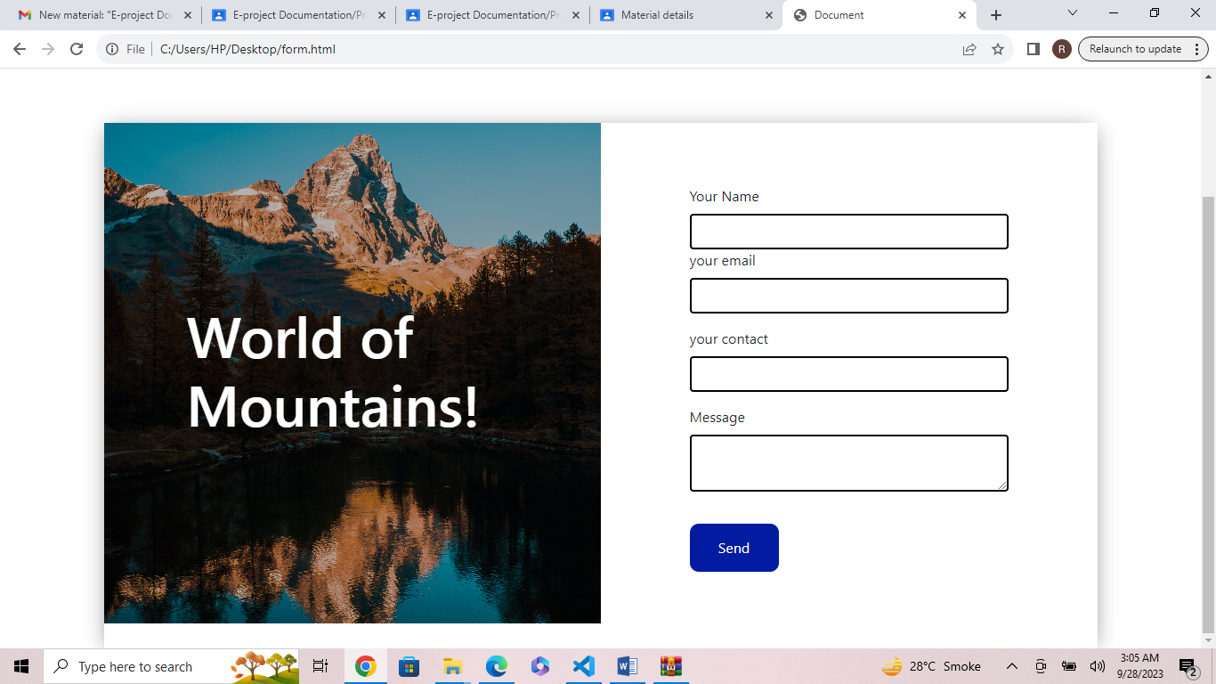

Figure 10: Contact us

We have added a contact us page so you contact us regarding any information or any question you have.

You can also contact us to book your appointment.

12.More Info: (more info.html)

* History

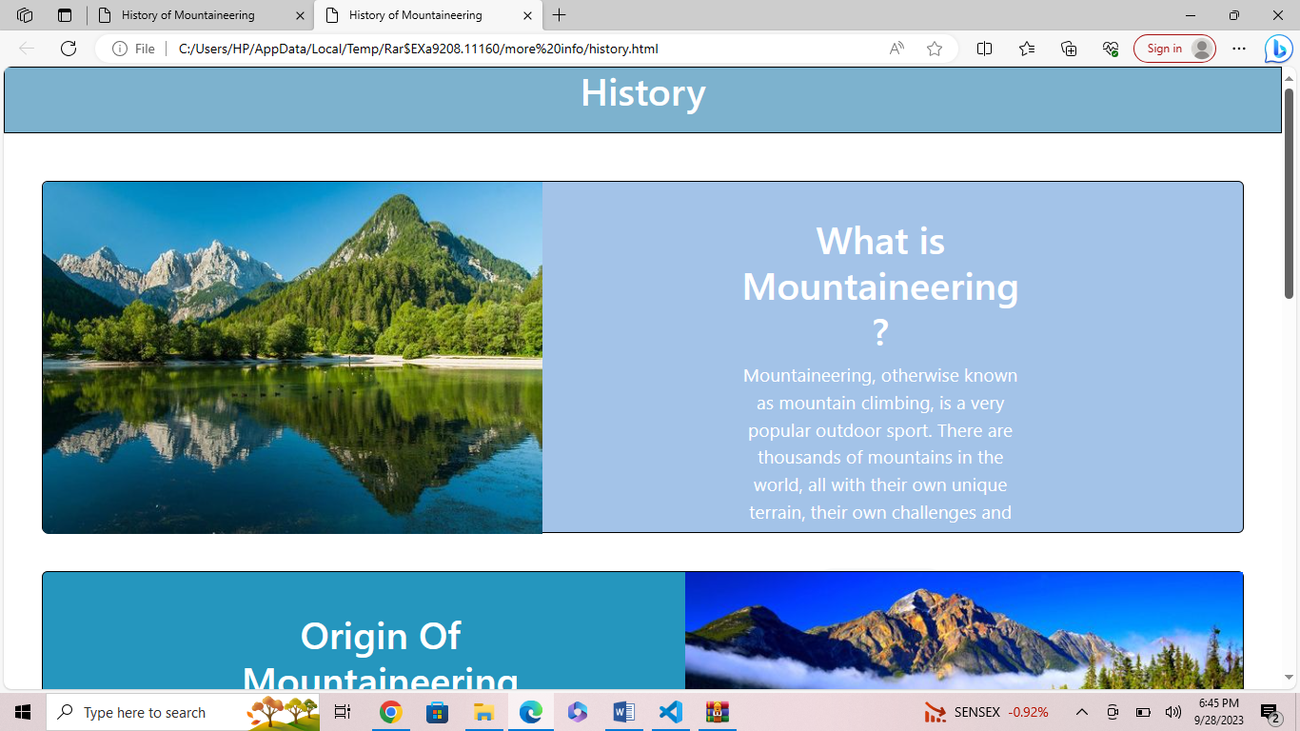

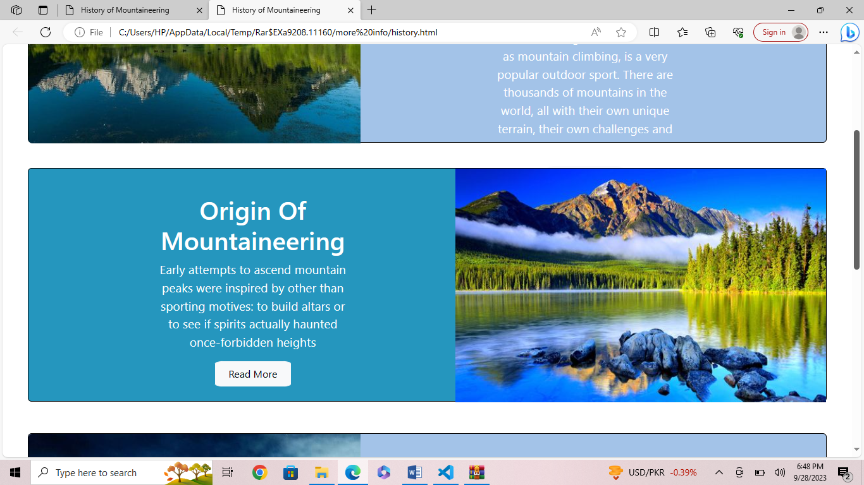

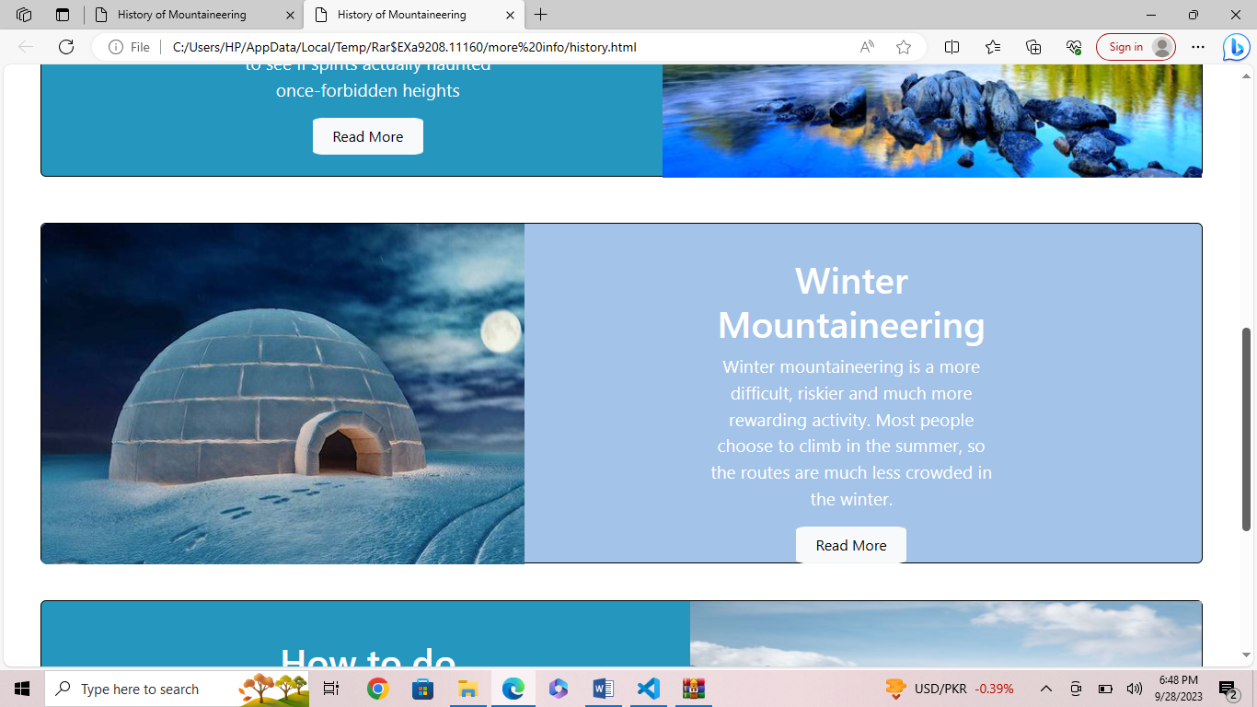

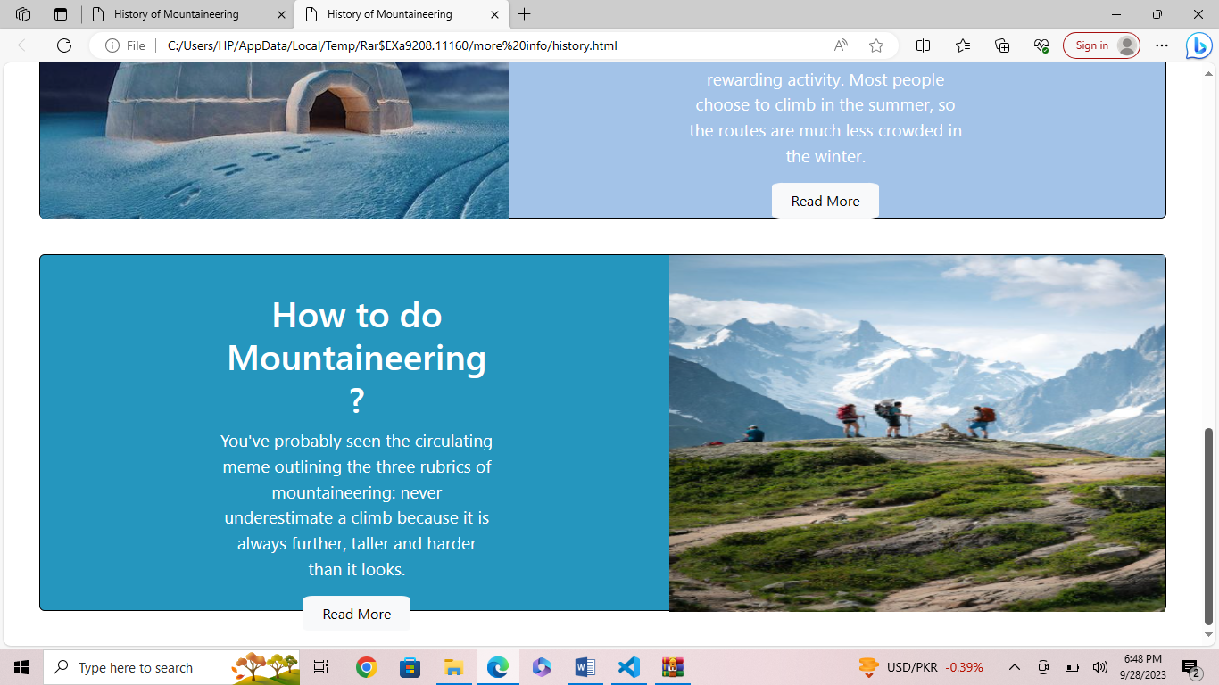

Figure 11,12 ,13 & 14:History

We have added history about mountaineering for people who are new in this adventure :

* Mountaineering, otherwise known as mountain climbing, is a very popular outdoor sport. There are thousands of mountains in the world, all with their own unique terrain, their own challenges.
* Early attempts to ascend mountain peaks were inspired by other than sporting motives: to build altars or to see if spirits actually haunted once-forbidden heights.
* Winter mountaineering is a more difficult, riskier and much more rewarding activity. Most people choose to climb in the summer, so the routes are much less crowded in the winter.
* You've probably seen the circulating meme outlining the three rubrics of mountaineering: never underestimate a climb because it is always further, taller and harder than it looks.
* Sheltering

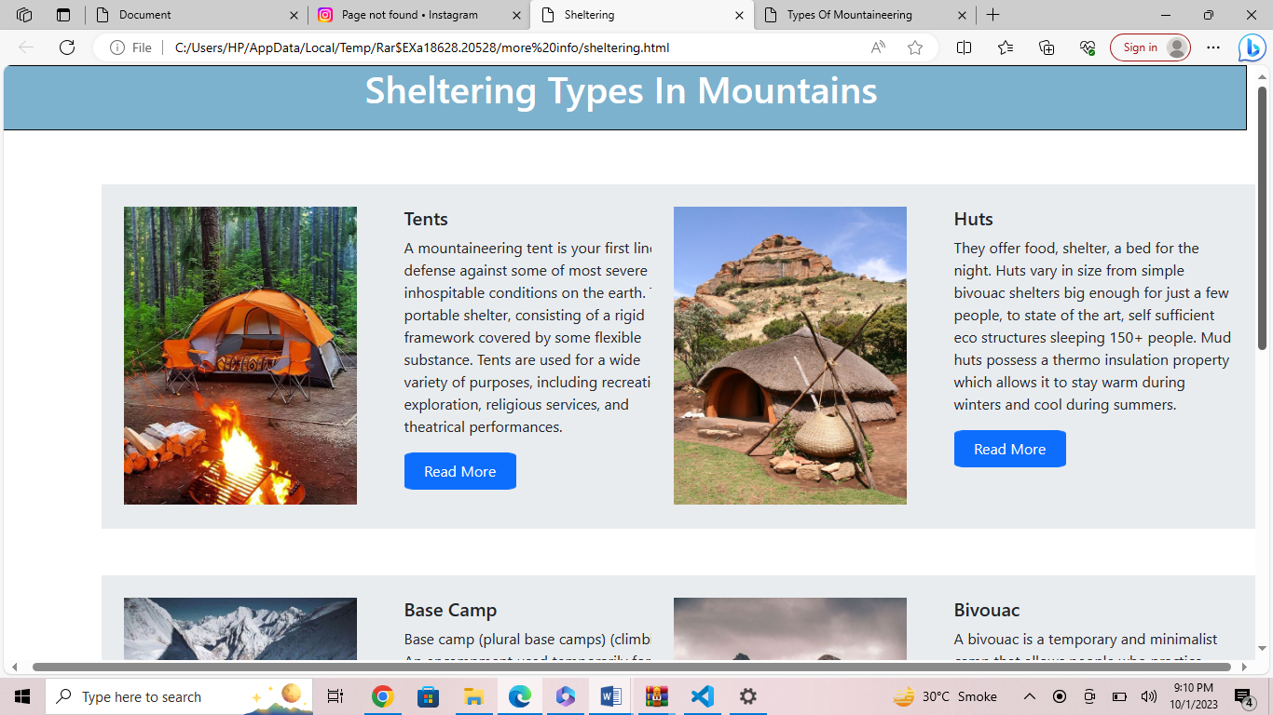

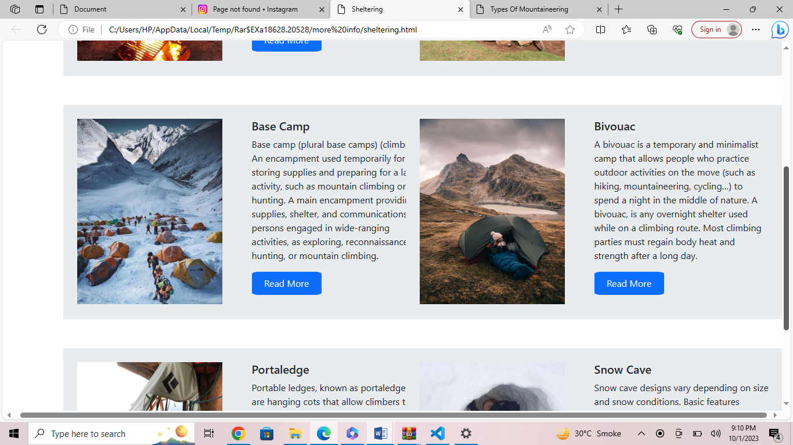

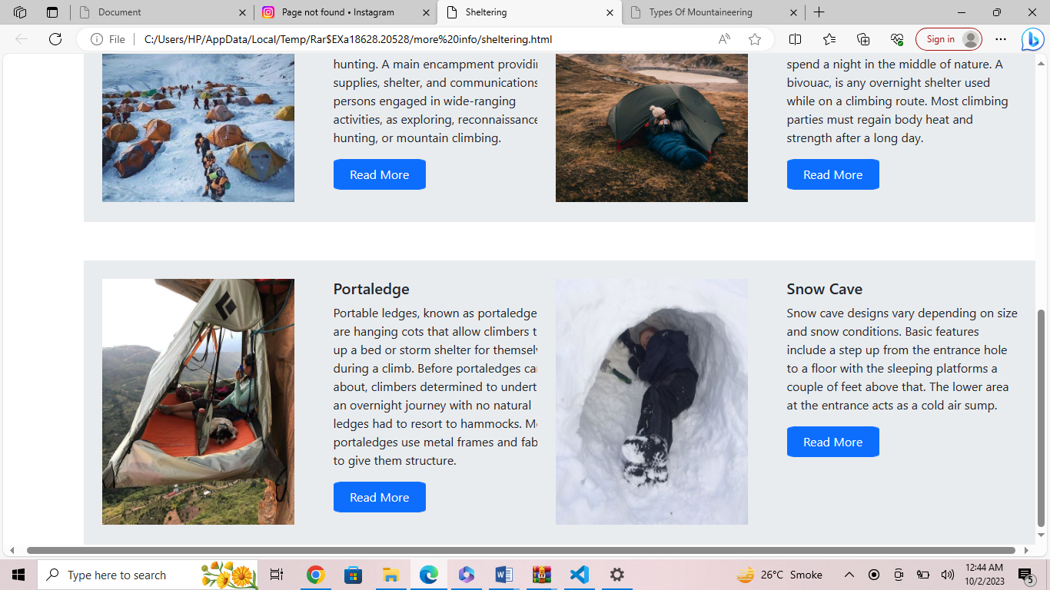

Figure 15 , 16 & 17: Sheltering

* A mountaineering tent is your first line of defense against some of most severe and inhospitable conditions on the earth. Tent, portable shelter, consisting of a rigid framework covered by some flexible substance. Tents are used for a wide variety of purposes, including recreation, exploration, religious services, and theatrical performances.
* They offer food, shelter, a bed for the night. Huts vary in size from simple bivouac shelters big enough for just a few people, to state of the art, self sufficient eco structures sleeping 150+ people. Mud huts possess a thermo insulation property which allows it to stay warm during winters and cool during summers.
* Base camp (plural base camps) (climbing) An encampment used temporarily for storing supplies and preparing for a larger activity, such as mountain climbing or hunting. A main encampment providing supplies, shelter, and communications for persons engaged in wide-ranging activities, as exploring, reconnaissance, hunting, or mountain climbing.
* A bivouac is a temporary and minimalist camp that allows people who practice outdoor activities on the move (such as hiking, mountaineering, cycling…) to spend a night in the middle of nature. A bivouac, is any overnight shelter used while on a climbing route. Most climbing parties must regain body heat and strength after a long day.
* Portable ledges, known as portal edges, are hanging cots that allow climbers to set up a bed or storm shelter for themselves during a climb. Before portal edges came about, climbers determined to undertake an overnight journey with no natural ledges had to resort to hammocks. Most portal edges use metal frames and fabric to give them structure.
* Snow cave designs vary depending on size and snow conditions. Basic features include a step up from the entrance hole to a floor with the sleeping platforms a couple of feet above that. The lower area at the entrance acts as a cold air sump.

* Types of Mountaineering

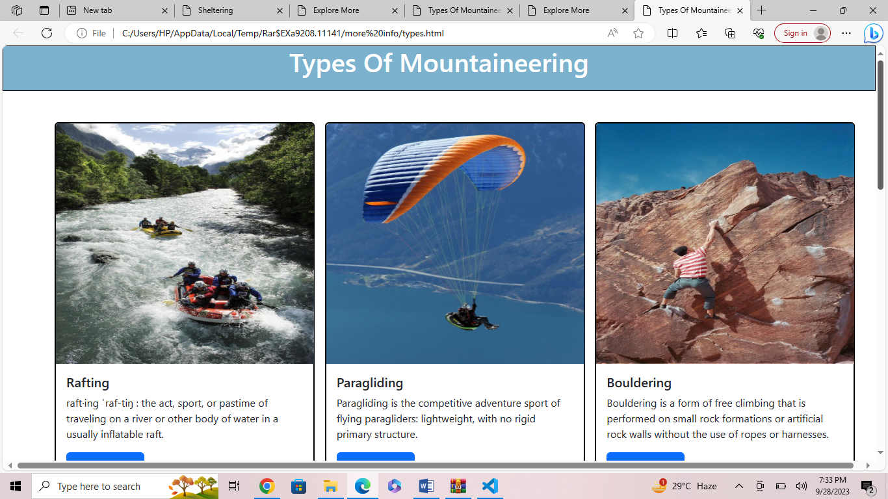

Figure 18: Rafting, Paragliding & Bouldering

* raft·​ing ˈraf-tiŋ : the act, sport, or pastime of traveling on a river or other body of water in a usually inflatable raft.
* Paragliding is the competitive adventure sport of flying paragliders: lightweight, with no rigid primary structure.
* Bouldering is a form of free climbing that is performed on small rock formations or artificial rock walls without the use of ropes or harnesses.

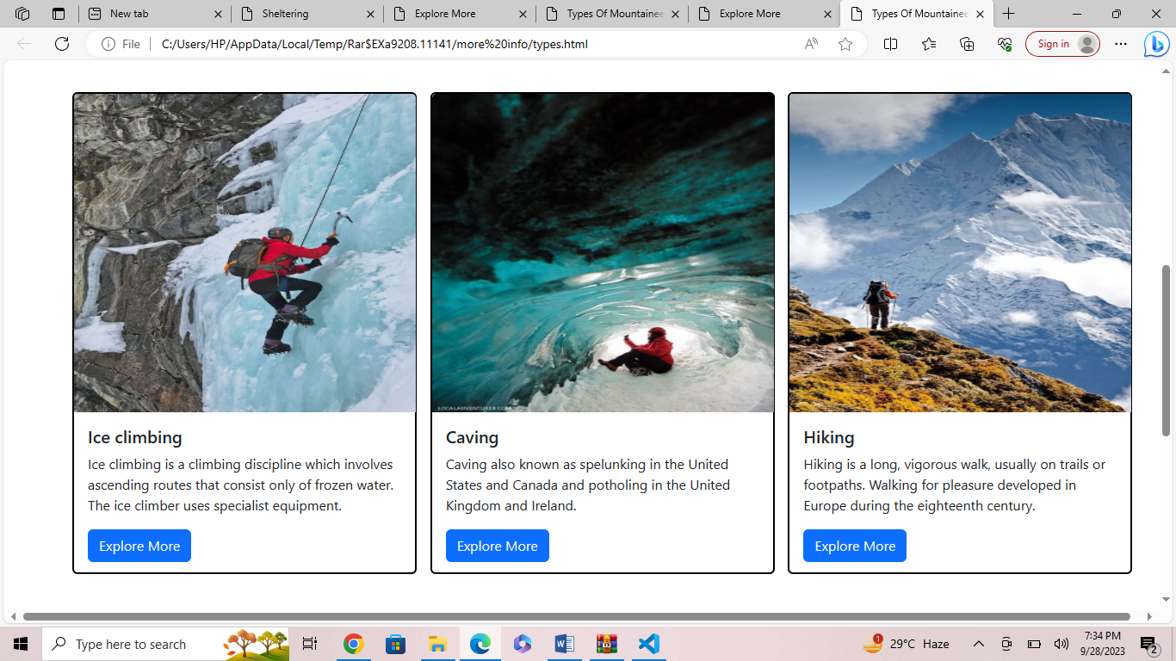

Figure 19: Iceclimbing , Caving & Hiking

* Ice climbing is a climbing discipline which involves ascending routes that consist only of frozen water. The ice climber uses specialist equipment.
* Caving also known as spelunking in the United States and Canada and potholing in the United Kingdom and Ireland.
* Hiking is a long, vigorous walk, usually on trails or footpaths. Walking for pleasure developed in Europe during the eighteenth century.

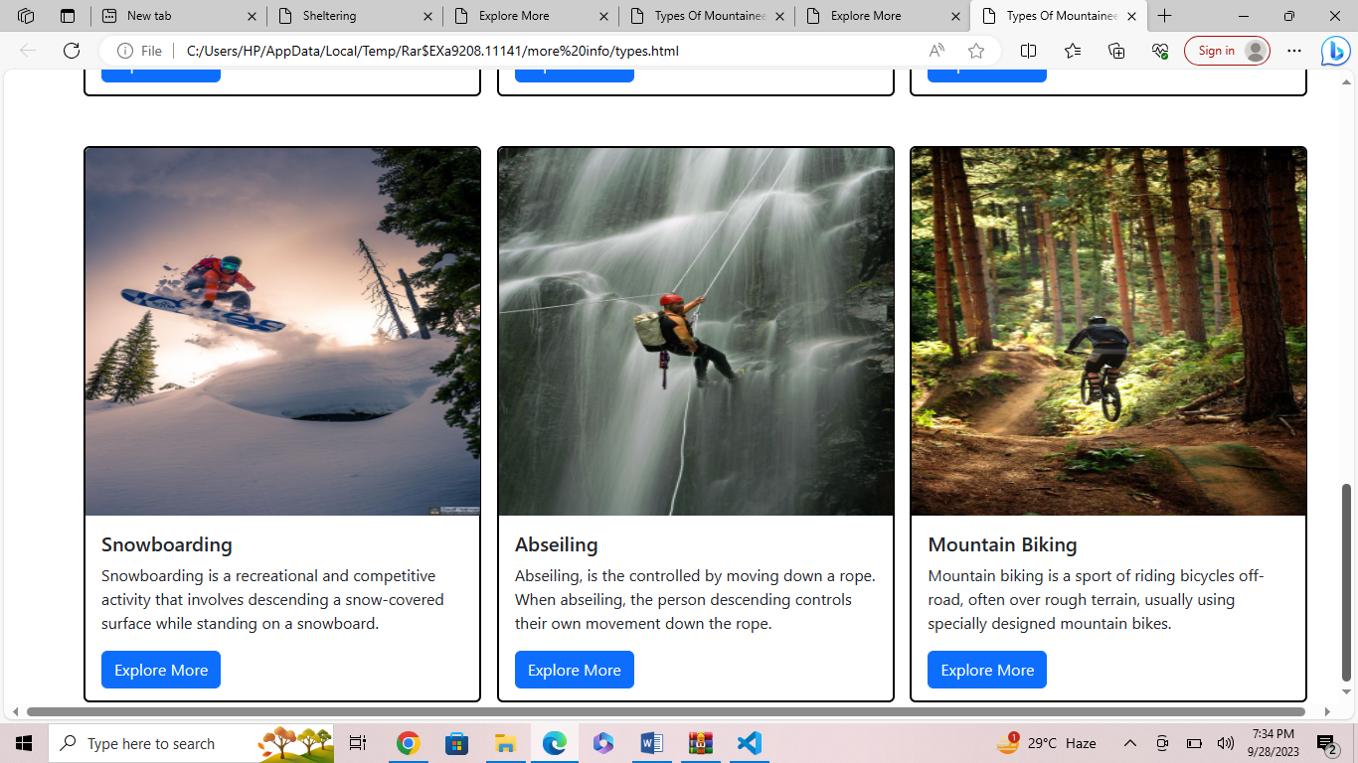

Figure 20: Snowboarding, Abseiling & Mountain Biking

* Snowboarding is a recreational and competitive activity that involves descending a snow-covered surface while standing on a snowboard.
* Abseiling, is the controlled by moving down a rope. When abseiling, the person descending controls their own movement down the rope.
* Mountain biking is a sport of riding bicycles off-road, often over rough terrain, usually using specially designed mountain bikes.

13. Footer:

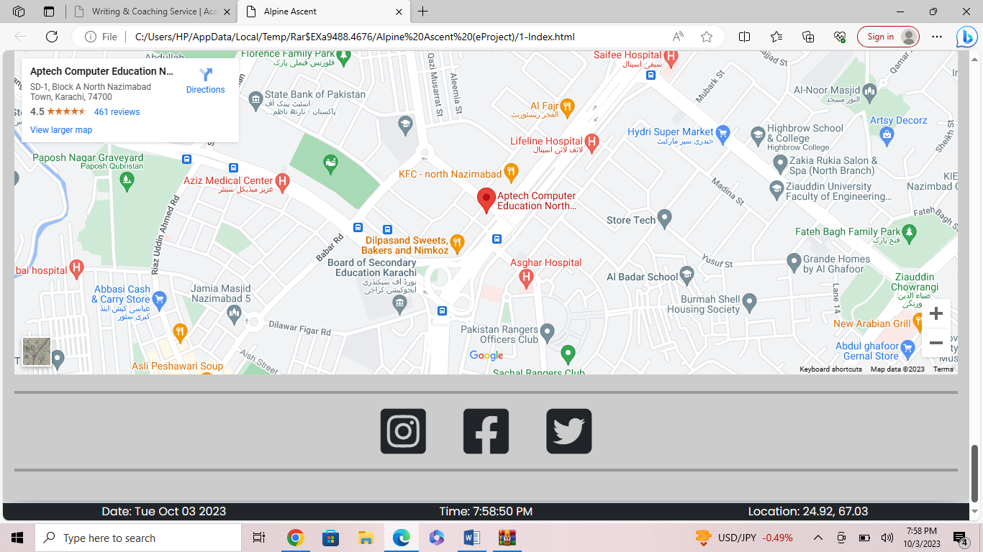

Figure :21 footer:

A map for location and current date and time is added in the end of the website and effects of Facebook Instagram and twitter are also mentioned for making the website attractive.